BRM/Safety Nets Programs for Fruit & Veg / Edible Hort

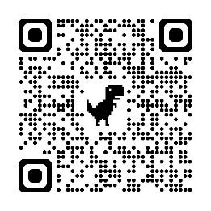
Self-Directed Risk Management Program (SDRM)
Ontario's SDRM program helps producers manage risks beyond their control, like fluctuating costs and market prices. Increases to program payments are scheduled for 2025, 2026 and 2027.

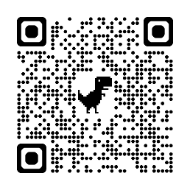
Crop Insurance / Production Insurance
Production Insurance covers production losses and yield reductions caused by insured perils. Depending on the plan, coverage is available on a total-yield or acreage-loss basis. Producers can choose the type and level of coverage that best meets their needs.

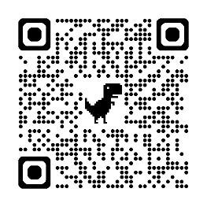
AgriStability
AgriStability covers large margin declines caused by production loss (particularly relevant if your crop doesn’t have crop insurance), increased costs or market conditions. If a producer’s margin falls below 70 per cent of their recent average, AgriStability helps to offset the difference. AgriStability enrolment can satisfy your security requirements for the Advance Payments Program, even if your farm does not use crop insurance.

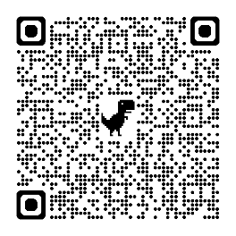
AgriInvest
AgriInvest is a savings account that producers can use to either cover small income declines or support other investments. Each year, producers can deposit up to 1 per cent of their Allowable Net Sales (ANS) into a bank account and receive a matching government contribution. Producers can withdraw funds at any time.

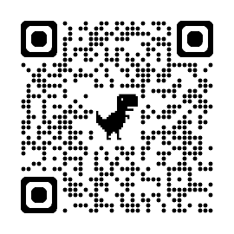
Advance Payments Program (APP)
The APP program supports the provision of cash advances to producers across Canada. Eligible farms can receive up to $100,000 interest-free in the 2025 Program Year, with an additional $900,000 available at Prime Interest Rate, for a total of $1,000,000.

