Award of Merit 2026 Nomination Form

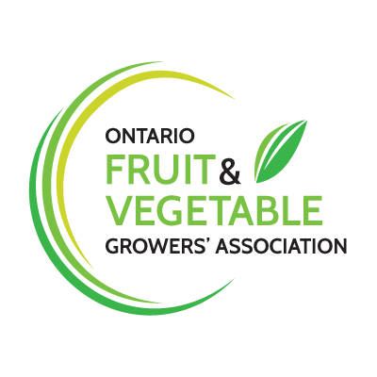
The OFVGA Award of Merit is our way of recognizing the outstanding contribution made by an individual or organization to our fruit and vegetable industry. This recognition may include the strategic leadership, technical input, and/or the dedication shown by this person or organization to our fruit and vegetable sector.
The winner will be announced at the OFVGA’s Annual General Meeting that will take place in Niagara Falls, Ontario on February 17th, 2026
Nominee Information: For the 2026 Award of Merit, I nominate: (please print)

Name:
Address:
Phone: Email:

Reason for Nomination:

Nominator Information:

Name:

Address:

Phone: Email:

Please return completed form to Ontario Fruit and Vegetable Growers’ Association
105-355 Elmira Road N., Guelph, ON N1K 1S5. Fax: 519-763-6604 or email dvanderzaag@ofvga.org

Objective
The objective of the OFVGA’s Award of Merit is:
- to recognize and encourage innovators at the grassroots level in the fruit and vegetable industry, whether it be in production, technology, or improved farm gate value
- to recognize a long-time advocate of the fruit and vegetable industry, who has continually reflected the values and integrity of the OFVGA
- to recognize the exemplary performance of an individual in the fruit and vegetable industry, who went above and beyond the call of duty
- to recognize an individual’s demonstrated unwavering commitment to the fruit and vegetable industry, who is not directly involved within the industry.

Innovation Categories
Examples of innovation include, but are not limited to the following:
- improved farm practices (eg. technology, business practices, processes, etc.)
- response to consumer demands (eg. value-added, marketing, strategic alliances)
- environmental stewardship
- energy innovations
- education and marketing of agriculture to society.

Selection Process
- Nominations will be received at the OFVGA
- Nominations will be reviewed for eligibility and prepared for review by the board of directors.

Eligibility Criteria
- must be a member farmer/producer, group of farmers, combination of agri-food businesses, or an agri-food related organization within the fruit and vegetable industry
- must be a resident of Ontario
- must be a Canadian citizen or permanent resident of Canada. Special Consideration will be given to:
• an individual involved in government or government department.

Nomination Process
- Nominations must be completed and submitted either electronically or in hard copy by 4:00 p.m. no later than January 17th, 2026
- Nominations must be submitted by e-mail or fax to:
Email: dvanderzaag@ofvga.org

Winner Announcement
- The Award of Merit nominator will be notified by January 30^{h}, 2026
- The Award of Merit winner will be presented at the banquet on February17, 2026
•The Award of Merit winner will also be announced in the March 2026 edition of The Grower and will be included in a feature article.

